**ONLINE PAYMENT GATEWAY**

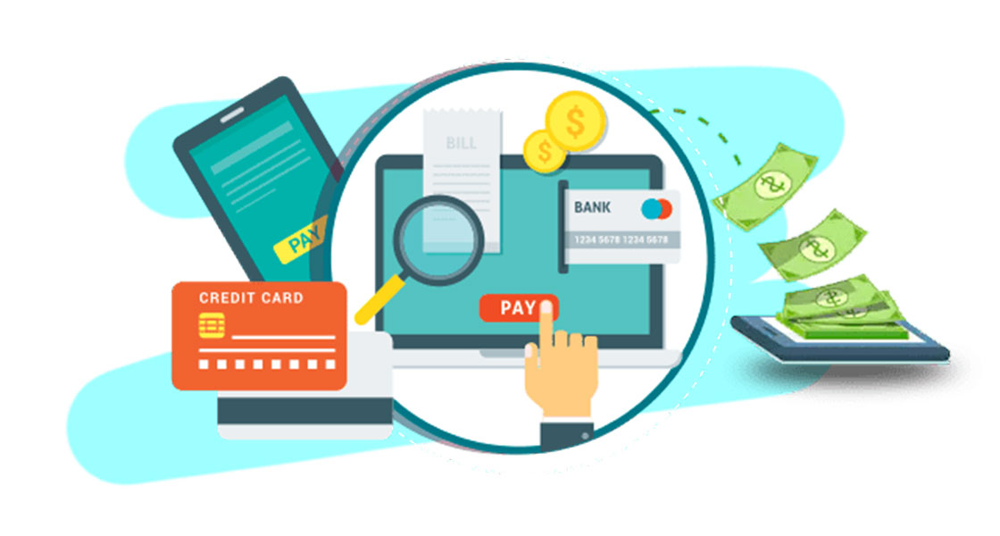**`Written By:**

**Hassan Arif (20L-1262)**

**Abdullah Ahmad(20L-1326)**

**Asad Ghouri (20L-1334)**

**Overview**

Basically we are aiming to build the international payment gateway in the future.So , first of all we must know about what the payment gateway actually is .So, some overview is given below to make you understand our project.

Online Payment Gateway is defined as a merchant service provided by an e-commerce application service provider that authorizes credit card or direct payments processing for e-businesses, online retailers, bricks and clicks, or traditional brick and mortar.

Online Payment Gateway also explained that A payment gateway facilitates a payment transaction by the transfer of information between a payment portal (such as a website, mobile phone or interactive voice response service) and the front end processor or acquiring bank.Payment gateways are a type of service that assists merchants in initiating ecommerce, in-app, and point-of-sale payments for a wide range of payment methods. The gateway is not directly involved in the money flow; instead, it is typically a web server to which a merchant's website or POS system is linked. A payment gateway frequently connects multiple acquiring banks and payment methods into a single system.

А payment gateway is the technology that captures and transfers payment data from the customer to the acquirer .

In simple terms, an online payment gateway is a network through which customers transfer funds.

**Non-functional requirements or NFRs**

Non-functional requirements or NFRs are a set of specifications that describe the system’s operation capabilities and constraints and attempt to improve its functionality.

**Performance Requirements**

Performance requirements define how well the software system accomplishes certain functions under specific conditions. Examples include the software's speed of response, throughput, execution time and storage capacity. The service levels comprising performance requirements are often based on supporting end-user tasks.

**Notify about successful Transaction within 10 sec:** If a user did a successful transaction then the system should notify the user within 10 sec instead of notifying after 1 day which may lead to misunderstanding between the users and the acquirer.

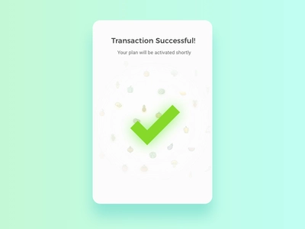

**Notify about failed Transaction within 10 sec:** System should send a notification if transaction failed with in 10 second to improve or enhance the quality of the product .So, this will also make the user satisfied and in comfort

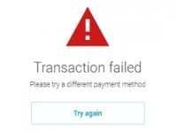

**Send OTP when the user wants it within 8 sec:** When user wants to logged in .System generates otp and send it to the users email / phone number with in 8 sec .As , this will firstly maintain the security as , After 8 sec the otp will not be considered secondly user didn't have to wait for too long to logged in into his / her account.

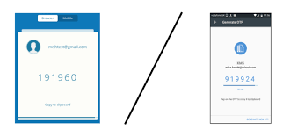

**Security Requirements**

We are talking about the non functional requirements of payment gateway .As, payment gateway deals with the transfer of payment data .So it is very important to make sure the best and most secure security requirements .

**Security question answering:** A security system for a product may ask questions that only the user knows the answer to. This can help verify a user's identity when they log into an account. Examples of security question topics include the color of your first car or your mother's maiden name.

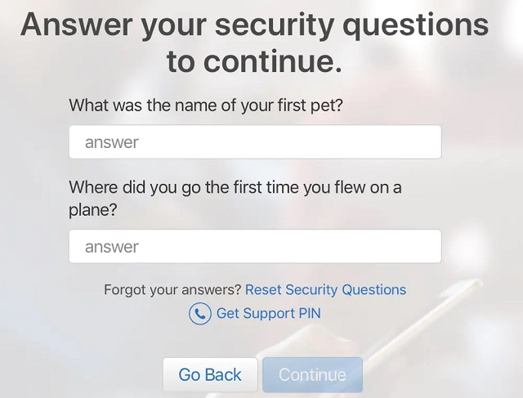

**Account locking:** After a certain number of login attempts, a security system may lock an account to protect a user's information from potential hackers. To unlock their account, a user can typically call the company to verify their identity and set a new password.

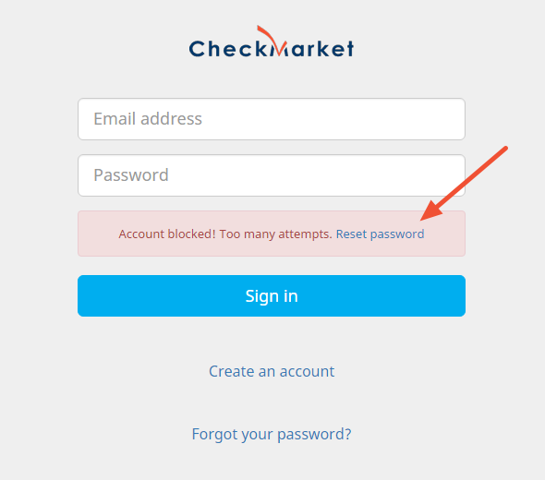

**Two Factor Verification:**Two-factor authentication verifies your identity by using two of three factors: something you know (like a passcode), something you have (like a key), and something you are (like a fingerprint).

\

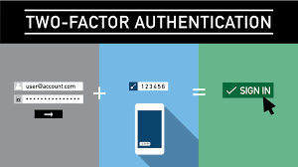

**Reliability Requirement**

Reliability is the probability and percentage of the software performing without failure for a specific number of uses or amount of time

.

**Scalability :The gateway must be scalable enough to support 1,000,000 visits at the same time while maintaining optimal performance.**

There are **two** ways to enable your system scale as the workloads get higher: horizontal and vertical scaling.

* **Horizontal scaling** is provided by adding more machines to the pool of servers.
* **Vertical scaling** is achieved by adding more CPU and RAM to the existing

machines.

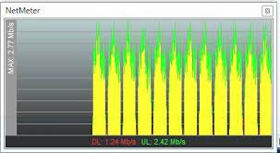

**Availability: The gateway will not face any network issues .**As people can do online payments and transactions whenever they want .So, our gateway will have a 15-20 min maintenance break in a 3 or 6 month peri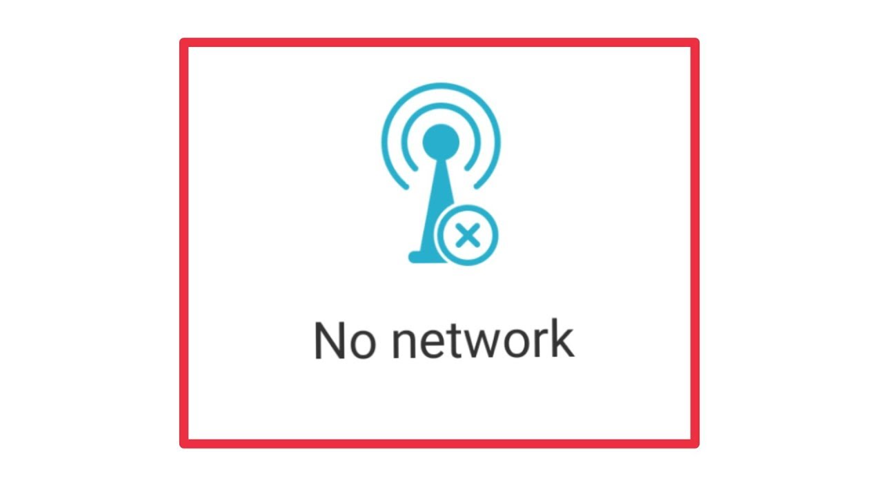

**Recoverability:The software should recover data within 1 minute after fault**

**occurred.** Recoverability is the ability to recover from a crash or a failure in the

system and return to full operations.



### **Portability Requirement**

Portability determines how a system or its element can be launched within one environment or another. It usually includes hardware, software, or other usage platform specifications. Put simply, it establishes how well actions performed via one platform are run on another. Also, it prescribes how well system elements may be accessed and may interact from two different environments.

**It can Integrate easily on every type of product All over the world :** This payment gateway is flexible enough that everyone can integrate it in his websites,app,or any software for payment transactions online.This will help the people to do international transactions.



**Environmental Requirement**

Environmental requirements limits the effect that external environment (natural or induced) is to have on the system, and/o the effect that the system is to have on the external enveloping environment

**The gateway will be available 24/7 to the users.**There will be no issues which will make the gateway unavailable to the users(natural disasters) .Try to find out risks and then make better solutions to avoid such things.



**Operational Requirements**

These are about how to run the system. Logging, startup/shutdown controls, monitoring, resource consumption, back up, availability etc. etc.

**In cases of failed transactions, the system shall retry the transaction.**If our transactions failed there is an option when we got notified of retry transactions which will make this payment gateway useful and reliable to the user.So , instead of doing the previous steps and entering details user can do it by clicking on the retry button.

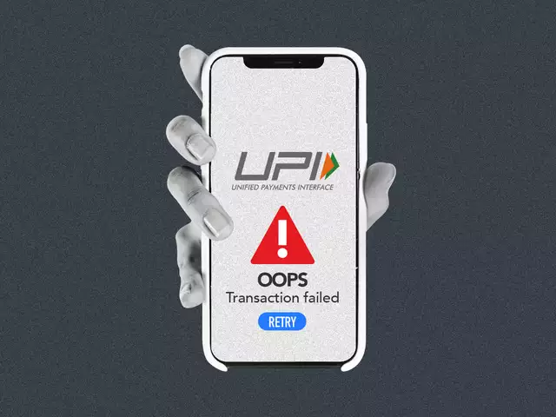

**Conclusions:**

After analyzing and researching we found out the major non functional requirements for our project (online payment gateway) .These non functional requirements will help us to improve our quality by maintaining security , reliability , performance , portability , operationality and many more requirements.So , after adding these requirements our project will be more efficient and accurate and useable.